Tech Startup System Documentation template
Table of contents
Introduction 1
Document change log 1
System overview 2
System components 2
System network diagram 2
Pouta Cloud 2
Hosts 2
Access List Rules 2
Users 2
Backup and disaster recovery 2
Services 2
Quality and operation requirements 2
Security 2
Introduction
This document contains the system operations documentation for the Server Technologies cloud environment.
The environment has been built in the Server Technologies course using CSC Pouta Cloud infrastructure.
The purpose of this document is to describe:
- system architecture
- network configuration
- hosts
- users
- services
- security configuration
The environment contains a Linux virtual machine hosted in CSC Pouta Cloud.

Document change log
Version | Date | Author | Description
1.0 | 10.3.2026 | San San Aye | Initial version. Ubuntu server deployed in CSC Pouta cloud.
System overview
The system consists of a cloud virtual machine running Ubuntu Linux hosted in the CSC cPouta cloud environment.
System components
The system contains:
- CSC cPouta Cloud infrastructure
- Ubuntu Linux virtual machine
• SSH remote access
• Linux server services

System Diagram
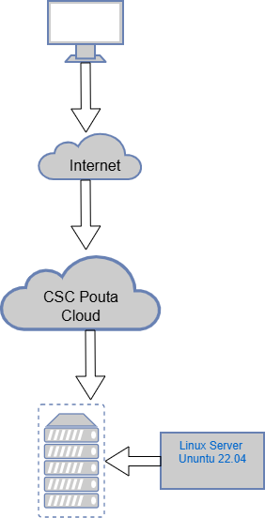

Pouta Cloud
The server infrastructure is hosted in:
CSC Pouta IaaS Cloud (OpenStack)
This environment provides:
- Virtual machines
- Network configuration
- Storage volumes
- Security groups

Host Name | IP | Description
linux-server | 192.168.1.228 | Ubuntu 22.04 cloud server running in CSC Pouta
Access List Rules
NOTE: Don’t open SSH to all the world. Limit to EduVPN, Tuni a choice of IP addresses, perhaps your home IP.
From | Port | Description
EduVPN / TUNI network | 22 (SSH) | SSH access to server
SSH access is restricted to trusted networks
User | Sudo | Description
Ubuntu | YES | Default cloud user
sanaye | YES | Primary personal username of San Aye
Backup and disaster recovery
Snapshot for server backup
Root’s password saved to local computer
SSH keys backups saved version control
In case of failure
1.Restore snapshot
2.Recreate instance
3.Reattach storage
Information about the service. Host, port, DNS-name, directory, configuration, testing the service etc.
System Configuration : The server runs:Ubuntu 22.04 LTS,Linux kernel,OpenSSH server
Configu,ration is managed using standard Linux tools.

Security configuration
Put here details about how the security of the system has been ensured and implemented
SSH Configuration
SSH key authentication used
Password login disabled

Automated Updates
Ubuntu automatic security updates enabled using:
unattended-upgrades
Firewall
Firewall configured using UFW.
The server is protected by firewall rules that only allow necessary traffic.
Only SSH (port 22) is open for remote administration.
All other ports are blocked by default.

CMDB
In the local system: /data/cmdb
<< Configuration management database. >>
<<Version control repository for server configuration files.>>
<<Place the Git repo URL here >>

